

**NEWFORM IS COMING BACK TO THE SALONE DEL MOBILE**

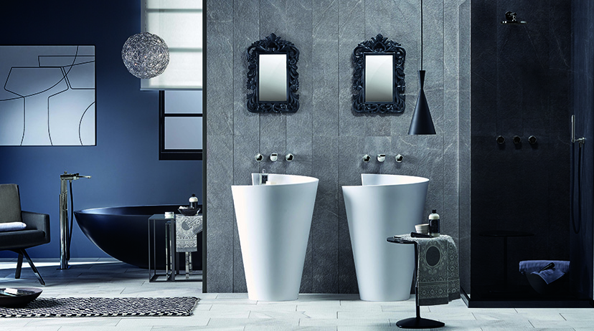

This year, the **Salone Internazionale del Mobile** in Milan will be the special occasion to meet **Newform,** which is more and more focused to innovative and functioning design proposals, offering a range of top quality products.

The company exhibits the new collections as **first preview**, the latest innovations for the **bath, the kitchen and the wellness,** reaffirming its role as **Italian style icon**. Research, Elegance and Trend are the keywords and inspirations to create new shapes, that allow to surprise and to distinguish from competitors.

The brand wants to amaze, explaining its philosophy of living with the new collections, bringing on the international stage the reply to the growing request from the worldwide market.

Inside the **Bath Stand,** Newform stands out for offering new and emotional spaces, playing with materials and colours in the environment, creating evocative and fascinating atmospheres and settings, which propose once again the well-being in the private sphere, as the home wellness or the contract field.

This appointment gives visitors the opportunity to meet the Brand and the product collections, as the latest **single-lever basin mixer** proposal, with minimal design and dynamics lines, designed for a modern and elegant space, or **the 3-hole collection**, with more classic style, conceived to satisfy the timeless request for a bathroom in ‘Old England’ style, and the professional kitchen **mixer taps**, available in a wide range of materials and finishes.

Newform waits for you from **12 to 17 April, at Salone del Mobile** in Milan - **Booth 22 / Stand G29-G31**.



**Newform Company Profile**

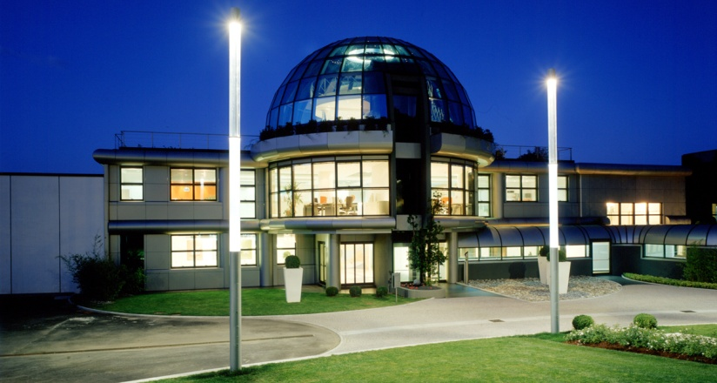Exclusivity, innovation and quality, together with attention to detail, are the hallmarks of the research for Newform. A story that passes through time, swinging between the past and the future. Newform is a guarantee of brand awareness and it is enhanced by a broader philosophy, identifying a real lifestyle able to give a touch of class and modernity to the bathroom and the kitchen. **Research** is the cornerstone of the great success of the company: the **design** conceived as the foundation of the product, the finest materials used and the eco-friendly **technology** create a top quality product, sophisticated and practical. The application of new technologies and the desire to express a touch of personal character make water available in new forms. That’s the philosophy adopted by Newform, with the aim to offer a product able to meet the needs of contemporary time, in a ritual approach to the bathroom and kitchen spaces.   
Newform offers a wide range of items, from faucets to ceramics, besides design oriented accessories that give a touch of style to the bathroom. The good design of the company allows you to create a unique and complete room for beauty lovers.   
Newform is also **wellness**. The brand focuses on all those who love taking care of themselves and giving moments of gratification, proposing them exclusive products: the Wellness collections, to feel lost in a wonderful sensorial experience.

Newform Press Office  
  
**Linda Barbolan  
Public & Media Communication**  
**Newform Spa**  
[media@newform.it](mailto:media@newform.it)  
Tel 0163.452011